AWS SYSTEMS MANAGER
AWS Systems Manager helps you centrally view, manage, and operate nodes at
scale in AWS, on-premises, and multicloud environments. With the launch of a
unified console experience, Systems Manager consolidates various tools to help
you complete common node tasks across AWS accounts and AWS Regions.

AWS Systems Manager is a management and automation service that helps
administrators:
Control EC2 instances remotely
- Automate operational tasks
- Manage patches/configurations
- Store secrets and parameters securely
- Troubleshoot systems without SSH
Use Case
A company has:
- Multiple EC2 Linux servers
- Developers currently use SSH with PEM keys
- Security team wants:
No public SSH access
Centralized access management
Ability to run commands remotely
Secure storage for application passwords
Architecture
Admin User

AWS Systems Manager

SSM Agent on EC2

Session Manager Run Command

Launch EC2 Instance
Got ot ec2 created ec2 instance
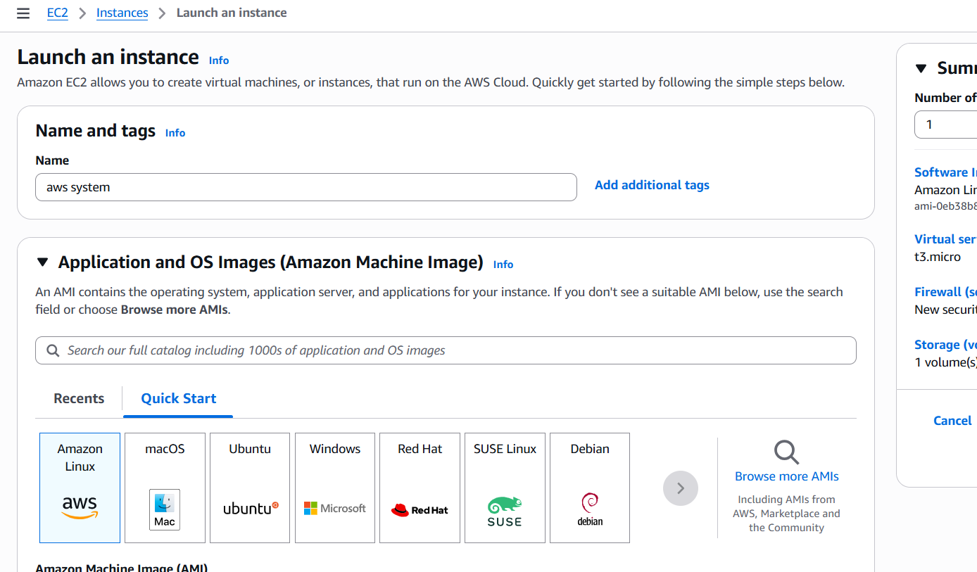
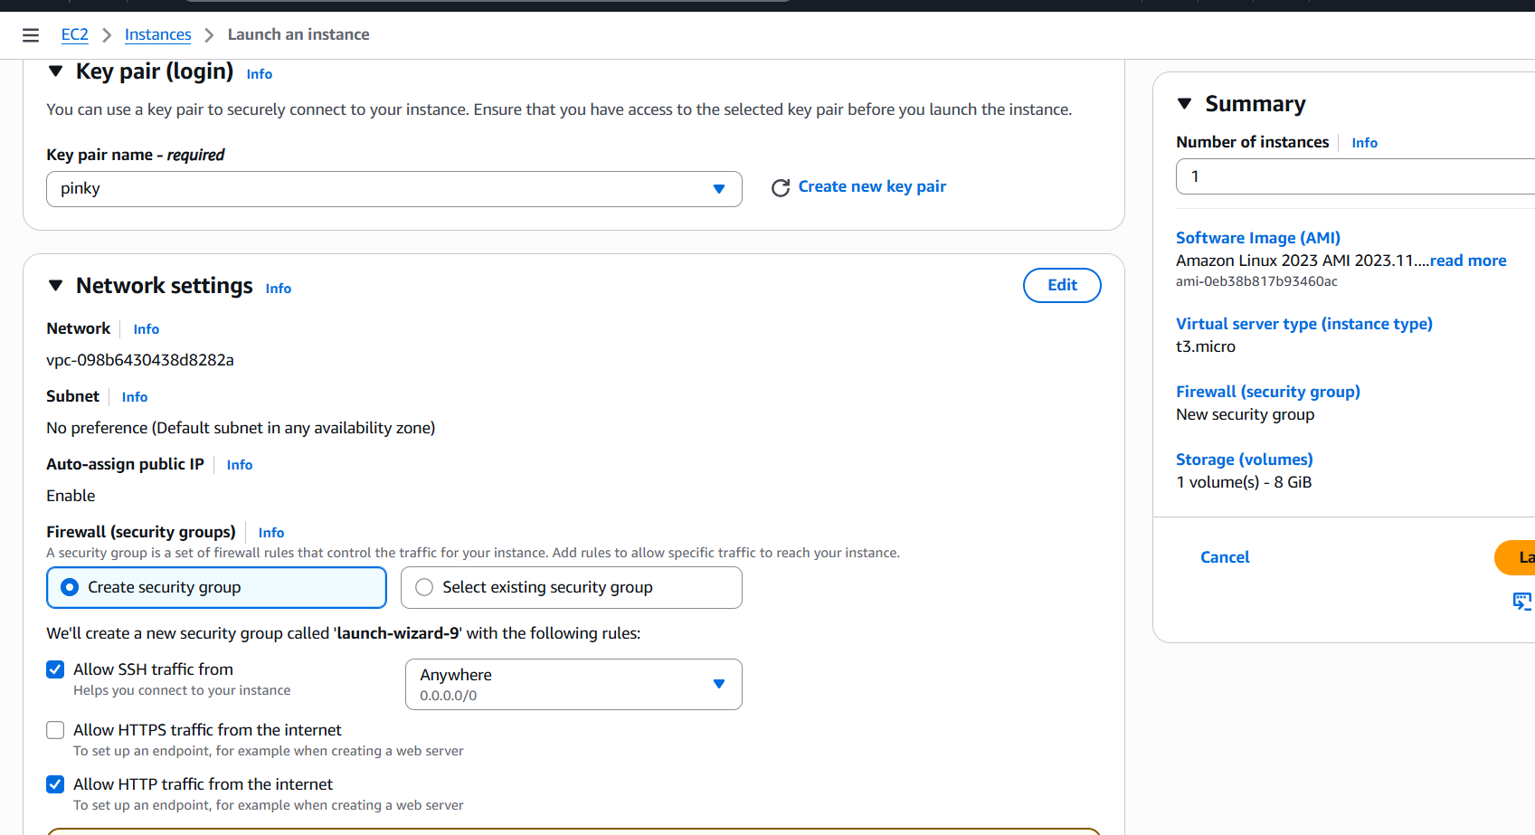
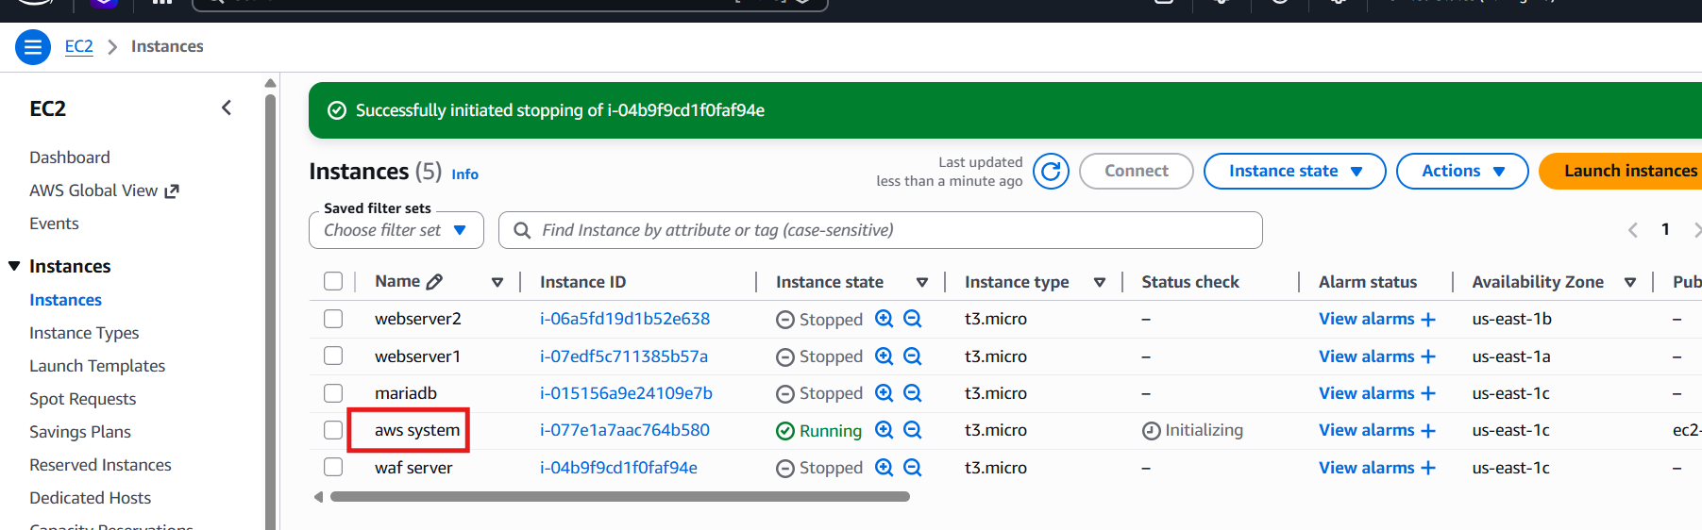
Attach IAM Role for SSM
Create IAM role go to IAM Roles Create Role
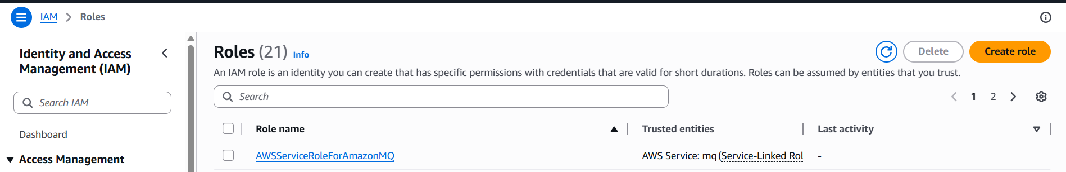
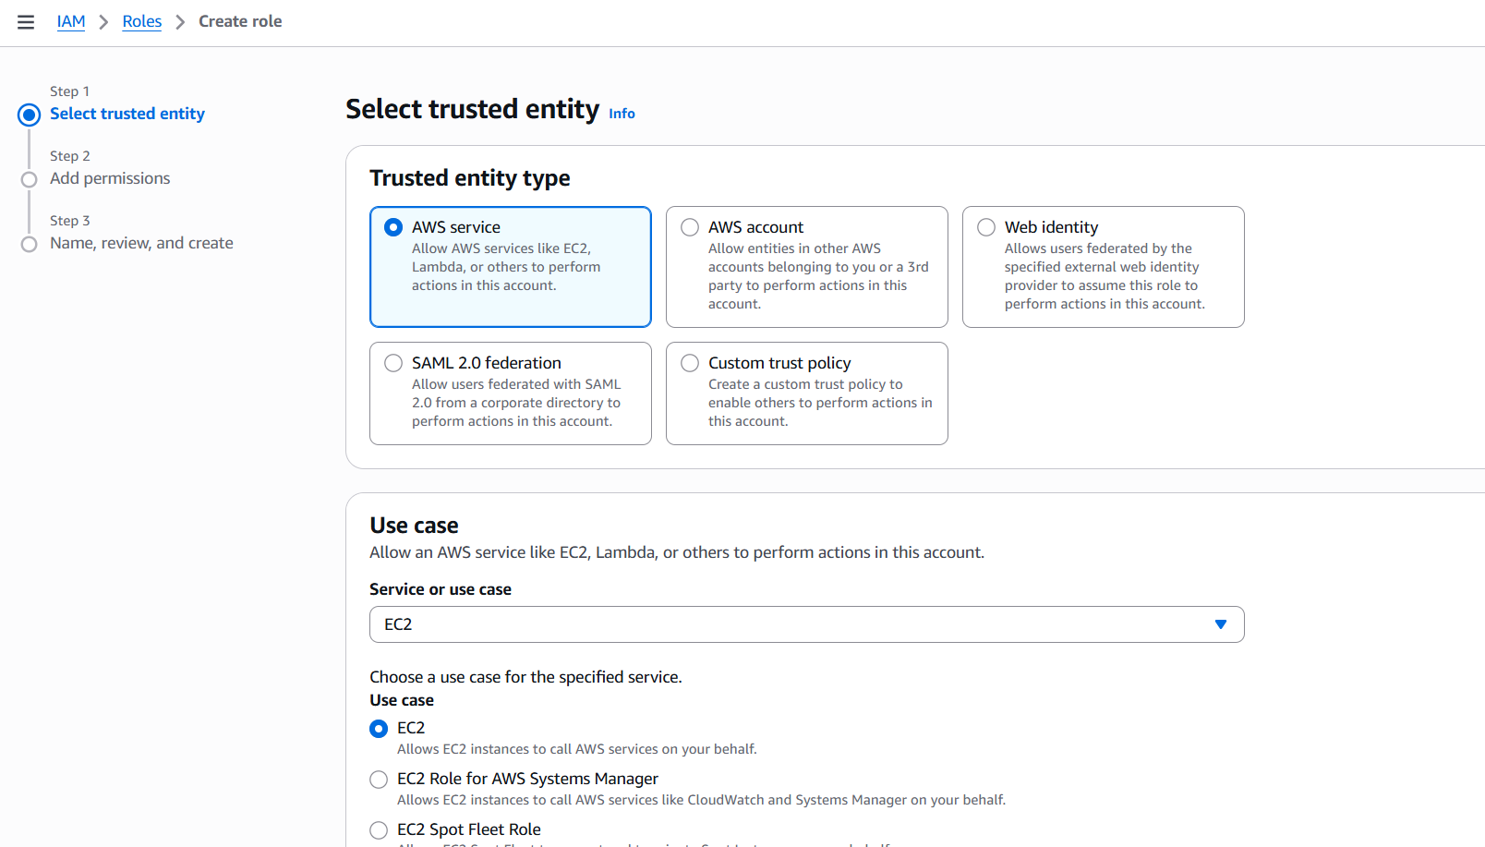
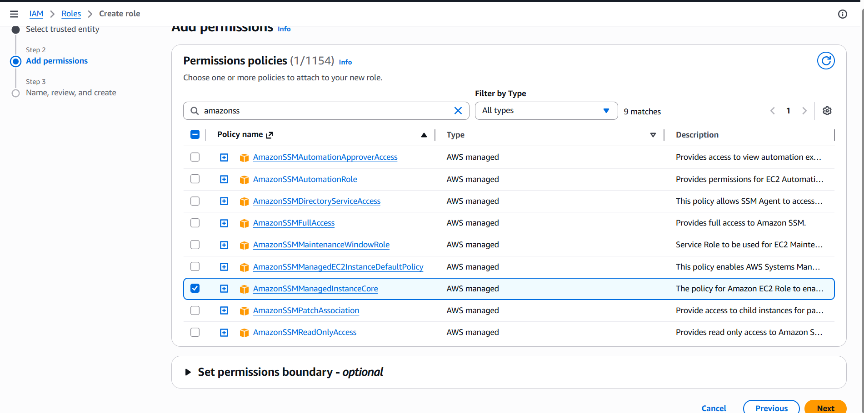
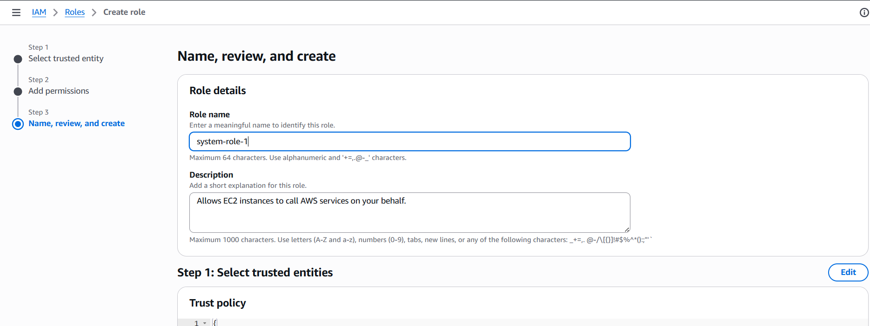
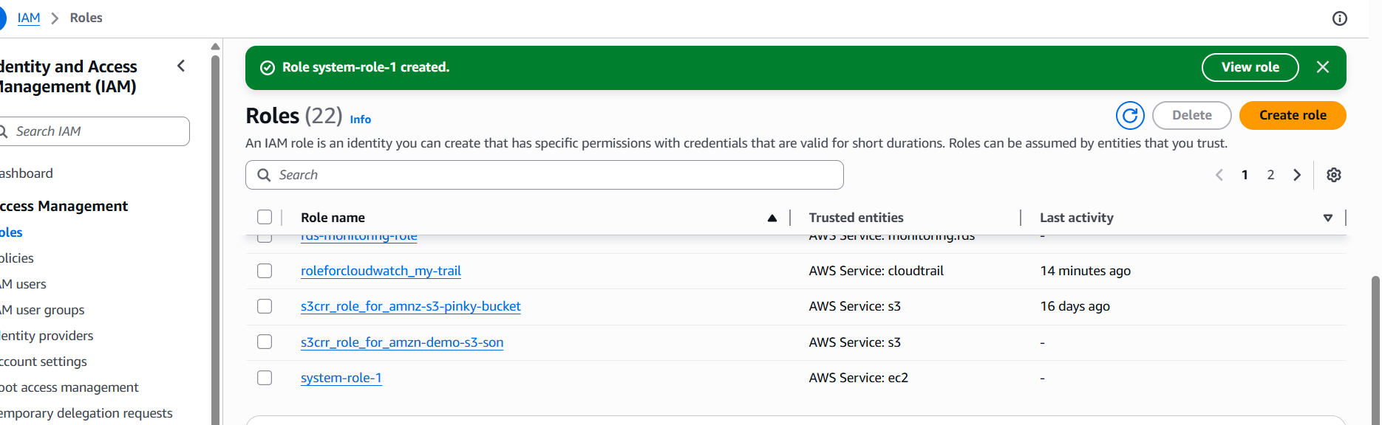
Role created
Verify Managed Instance in SSM
Go to AWS Console → Systems Manager Fleet Manager → Managed Nodes

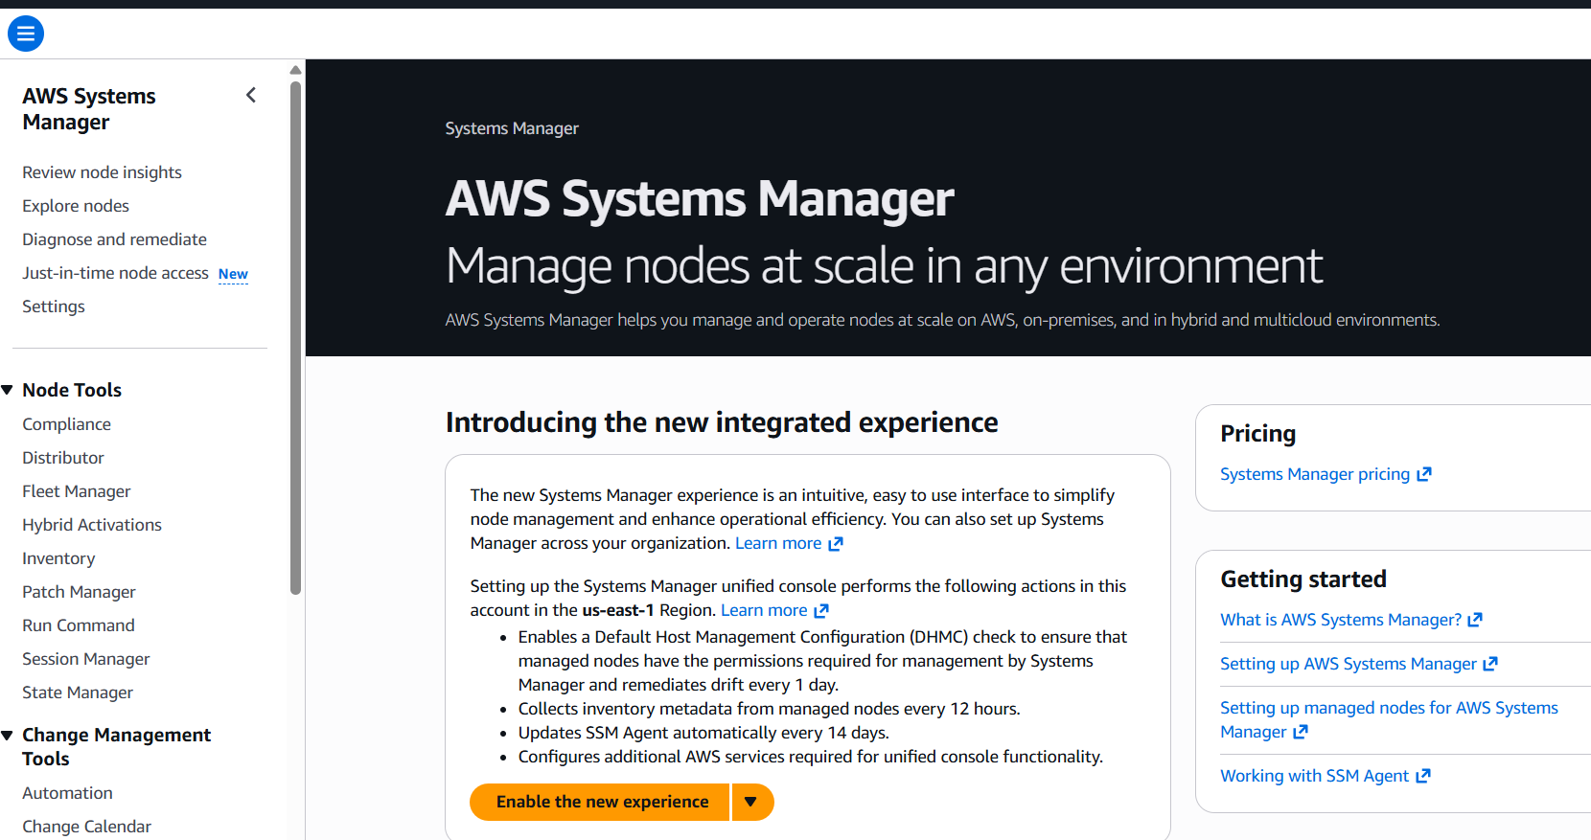
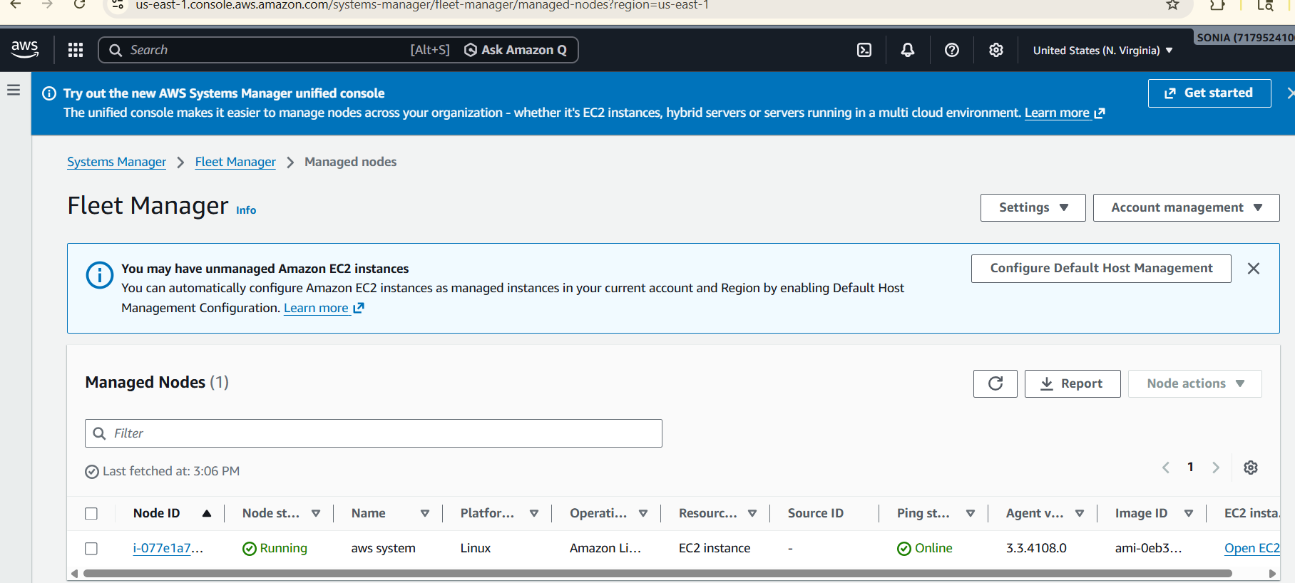
Connected to SSM Manager
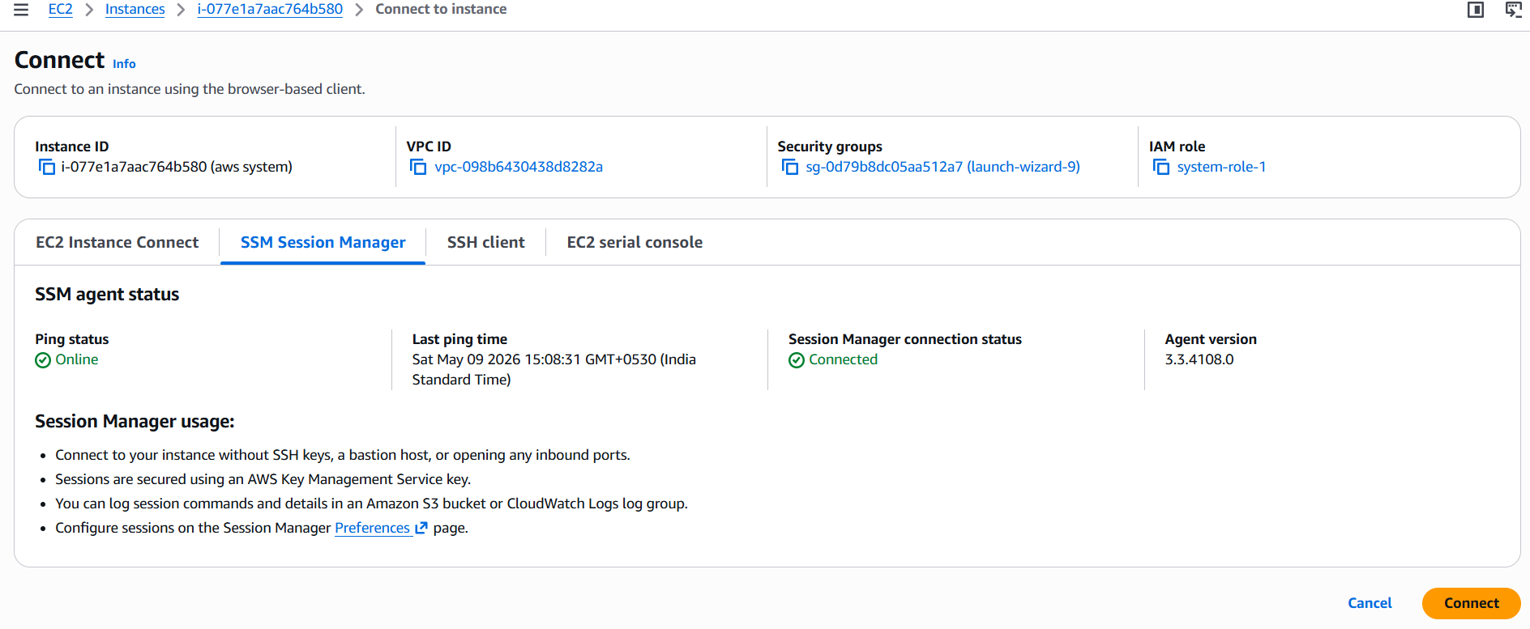
Ran few commands to verify and it is working
